This is an exercise in learning to "see" and to "describe." This Assignment has three parts. Right now you can see only part one. Once you complete and submit your answer to this, part two will become available for you to view. Once you complete and submit your answer to part two, then part three will become available to you. You may choose to complete them all in one session or to spread them out over a few days.

Assignment part one: Your assignment is to describe Barbara Kruger's 1983 photograph, "Untitled ("Surveillance is your busywork"). [See image below.]

Description is a data-gathering process.. In analyzing a visual image, the first task you have is to make sure you have looked at the piece carefully and fully. This assignment is a simple exercise in description or establishing the internal context of an image. You are not to interpret the image or to give your personal opinion of it, merely to describe. For descriptions to be meaningful, however, it is important to take note of everything that has done or included in making the image. Try to create a description that would help someone "see" the piece even if they were not able to view it. Your answer should be in essay format, free of spelling and grammatical errors, and approximately 100-200 words in length.

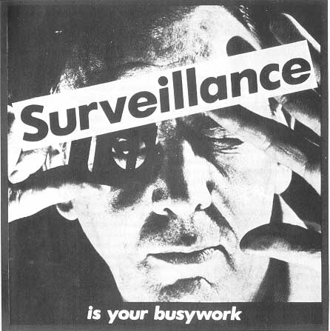

Assignment part Two: Good and full descriptions are the prerequisite of well-thought out interpretations. Part two of this Writing Assignment asks you to do a self-assessment of the description you wrote of Barbara Kruger's Untitled ("Surveillance is your busywork") , 1983. To do so: Read the following description of the same photograph and then write 200 to 300 words comparing your description to this one and giving yourself advice on where your description could have been improved. Also, note where you have been able to "see" things or to describe more clearly than the following description. Notice, too, when issues of terminology or knowledge of forms of production has hindered or helped your "seeing."

"'Surveillance' and Internal Context: This is a black and white photograph with words superimposed upon it -- 'Surveillance is your busywork.' A man is peering at us through a photographer's lupe, a magnifying device for closely examining negatives, contact prints, slides, and photographs. The lupe is a fixed-focus device, a cube, and he has it and his other hand against something, perhaps a pane of glass, a window, or a light table used for viewing negatives and transparencies. One of his eyes is closed, the other open. The light source is directly in front of his face, and it is harsh, revealing pores of skin and
stubbles of whiskers. He looks to be in his forties or fifties. He is intent and, on the basis of the photograph, would be difficult to identify. The photograph in 'Surveillance' . . . is dramatically lit and shot from a dramatic angle and distance--reminiscent of black and white Hollywood movies on late-night television, tough-guy cops-and-robbers movies.
The photograph is approximately square. It was shot either from a distance with a telephoto lens or from very close with a normal lens. . . . The word surveillance is larger than the other words, in black type on a white strip, pasted at a slight diagonal above the man's eyes. The phrase "is your busywork" is at the bottom of the image, in white type on a black strip. The words are a declaratory sentence.
Terry Barrett, Criticizing Photographs: An Introduction to Understanding Images , p. 105

Assignment part Three: The last part of this writing assignment calls for you to describe a 1988 painting by Faith Ringgold, Dancing on the George Washington Bridge (Acrylic on canvas, printed and tie-dyed fabric, 68" x 68"). Think about the self-assessment you did in Part Two of this writing assignment. What aspects of description do you think you could improve on? Work on those in this writing assignment. Remember that you want to describe everything the artist has done or included in the artwork and you want to describe it in a way that someone could "see" the work even if they weren't able to
view it. You should write 200 to 300 words, in essay format.
When you have completed writing your description of Dancing on the George Washington Bridge, reread it, compare it to the painting, and then in four or five sentences write what aspects you think you have described particularly well and what aspects of description you think you still need to work on.
Once you have done that you are finished with this Writing Assignment..

